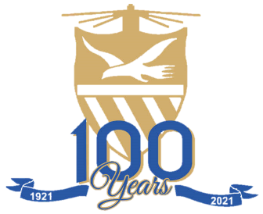
HOËRSKOOL PUNT
POINT HIGH SCHOOL

PROVISIONAL PROGRAM: CENTENARY CELEBRATIONS 2021
4 August 2021 – 8 August 2021

WEDNESDAY: 4 AUGUST 2021
14:30 – 18:00 Registration at school
(memorabilia for sale)
14:30 – 16:00 Boerewors rolls for sale / cash bar
17:00 till late “Ken-mekaar” function (school)
Braai packs for sale / cash bar

THURSDAY: 5 AUGUST 2021
10:00 – 13:00 Ex-scholars / ex-staff members may visit school
Photos and exhibition of history in staffroom
Coffee / Tea and sandwiches in “Vistank”
18:00 – 20:30 Big Brag (venue will be confirmed)
19:00 Switching on of lights (classes)

FRIDAY: 6 AUGUST 2021
12:00 – 14:00 Mini Brag (Van Riebeeck stadium)
18:00 till late Steak braai (school)
Cash bar

SATURDAY: 7 AUGUST 2021
08:00 – 17:00 Interschools (Van Riebeeck stadium)
VIP tent and allocated seating area for ex-scholars / ex-staff members
(Curry and rice / Soup and bread available in tent)
17:00 Cash bar at clubhouse after games

SUNDAY: 8 AUGUST 2021
10:00 – 12:00 Church service in school hall
(light refreshments before departure)
Gholf for those interested

